Matteo Matta matricola 70/83/65490

LAB05 – group 0
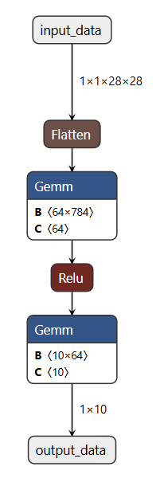
The DNN topology for the group 0 was that one report in Figure 1. It’s job is to recognize mnist digit inputs given in .bin format.
The DNN consists of the following layers:
- Inputs: .bin file with 784 pixels (each 16 bit wide);
- Flattening operation: transforms the bidimensional info into a flat array;
- A first Gemm operation;
- A Relu operation: transforms negative values in zeros;
- A second Gemm operation;
- Output: 10 scores with the higher one representing the recognized digit.

The format selected for weights, biases and activations is Q8.8. The considered DNN topology demonstrated pretty well behaviour at recognize the provided digits with an accuracy of the 90% (number 5 always misclassified with a 3)).
However, some tips and tricks have been implemented for optimization.
Figure 1: DNN Topology

Tip1: sending a Q0.8 version of the images
As UART transmission is not a fast form of sending data, making the data as light as possible could lead to huge improvements in speed, especially with huge amounts of data. As reported in the LAB’s paper, we were able to perform a Q.8.8 -> Q0.8 conversion given that the 8 MSBs of each pixel were always 0x00.
The conversion has been performed on the board itself. The related code may be commented/uncommented as you like if you don’t need the conversion of the image at the beginning and you want to provide an already converted image to the DNN (maybe because you did it once and you saved the converted image).
Once the image has been sent to the microprocessor, this last will re-expand it to restore the correct format data (short int) for feeding the DNN (as the DNN has not been already dimensioned for 8bit pixels wide).
The goal improvement is visible displaying “flattening” metric (as it coincides with the “receiving image from UART” operation) in Figure 2 and 3. As expected, the receiving time for the image is smaller in the case it is sent as Q0.8 format rather than in Q8.8 format.
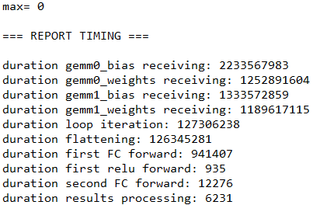
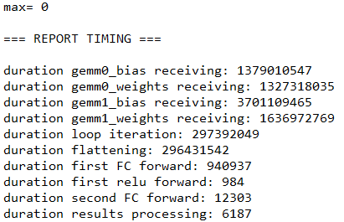
Figure 3: times after sending the image in Q0.8 format
Figure 2: times of sending image in Q8.8 format

Tip2: Saving time and memory modifying the system to another format (Q4.4 format)
The LAB’s paper reported another trick to save time during transmission and memory.
In fact, the most significant byte of weights and biases were always 0xFF or 0x00 (hence, the integer part was just representing the sign) and the information could be represented using a different data format (like Q1.7 or other formats) and so, allowing to scale the information from a 16 bit format to a 8 bit one. We are basically dividing by two the information size of biases, weights and inputs at the price of less precision but getting benefits in time (for transmission and execution) and in memory (as our DNN can be so reduced in size).
As done in Tip1, the format conversion to Q1.7 for biases, weights and inputs was performed on board, with some code at the beginning of the main() that can be commented if your weights, biases and inputs are already converted into the desired format.
It is supposed to feed the program with the converted data. So, the DNN was dimensioned to handle information represented by 8 bit (instead of 16) and in Q1.7 format. However, the DNN with the Q1.7 format demonstrated poor classification accuracy due to its small representation range of [-1, 0.99] of the output that probably doesn’t allow to handle mac operations with biases and weights that exceed this range limit going to saturate.
So, other data formats with a greater integer part have been considered to make the dynamic range bigger. Naturally, all the system configurations were adjusted to the new data format.
Q2.6 format showed poor accuracy even if it was slightly better than Q1.7.
Q3.5 format demonstrated better accuracy than Q2.6 but was not enough.
Finaly, Q4.4 showed the best accuracy value with 90% (“5” digit misclassified with a “2”).
In Figure 2 and Figure 3 are presented the time difference between each operation for the classification of the digit “0” for the DNN with Q4.4 format and Q8.8 format respectively (both with activated vectorization to exploit SIMD). In yellow, the difference in time between the loop iteration of the two solutions.
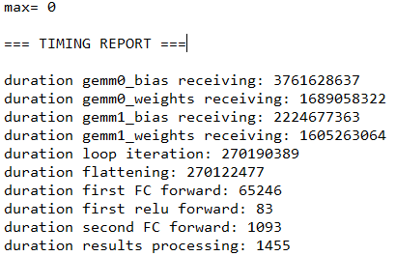
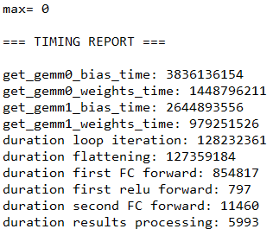
Figure 3: "0" classification without any optimization and Q8.8 format
Figure 2: "0" classification with optimization and Q4.4 format

